Test Case: tc006_SPX_Dev5_Crear_Requisicion_Spot_Tipo_Cobro_Proyect_Urgent
Step 1 - Enter username and password and click to button Enter: Credentials Entered
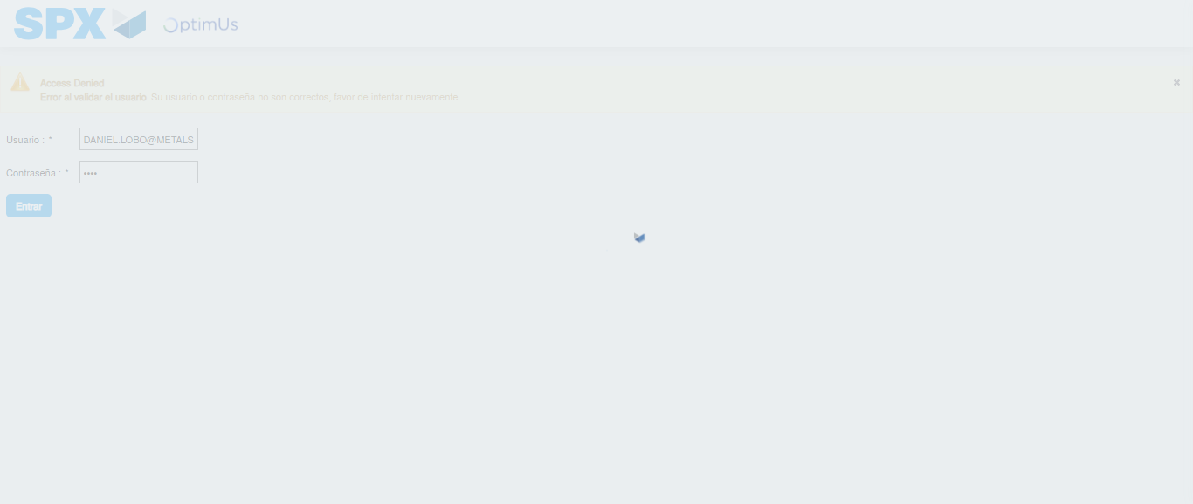Image file-name: QC_Testing-tc006_SPX_Dev5_Crear_Requisicion_Spot_Tipo_Cobro_Proyect_Urgent-1784214461890

Step 2 - Select to UEN and Access to Spot Buy Requisitions : UEN Correctly selected and Correct access
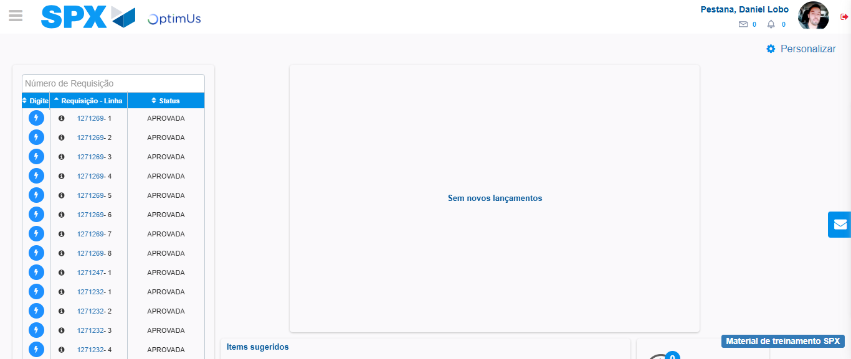Image file-name: QC_Testing-tc006_SPX_Dev5_Crear_Requisicion_Spot_Tipo_Cobro_Proyect_Urgent-1784214488434

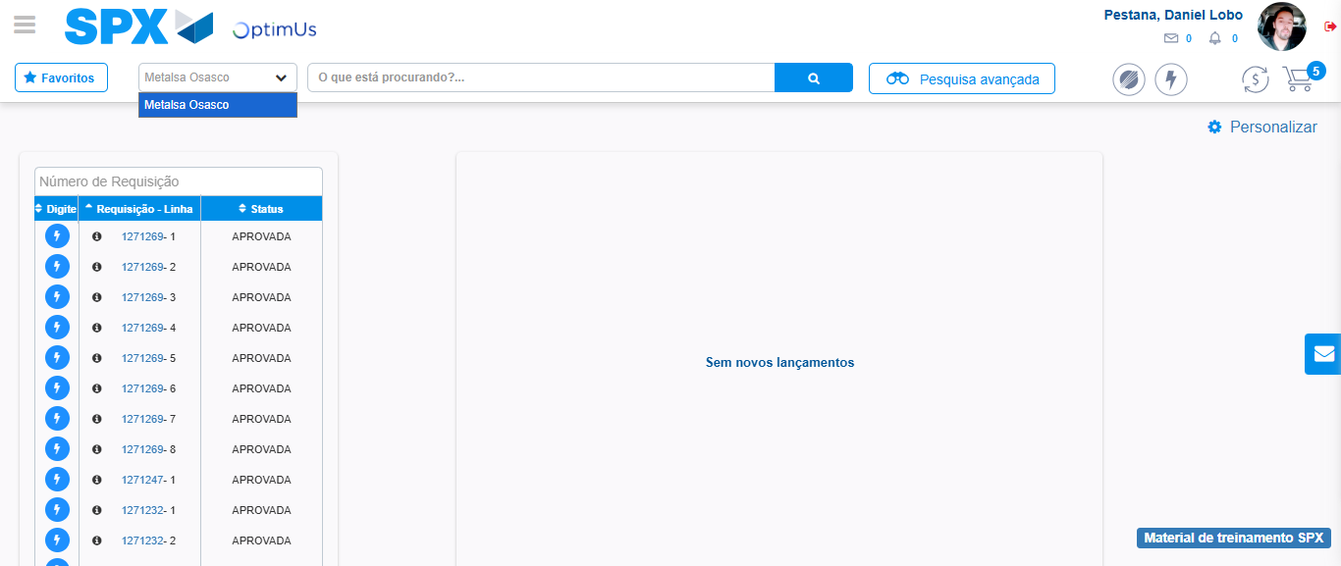Image file-name: QC_Testing-tc006_SPX_Dev5_Crear_Requisicion_Spot_Tipo_Cobro_Proyect_Urgent-1784214491175

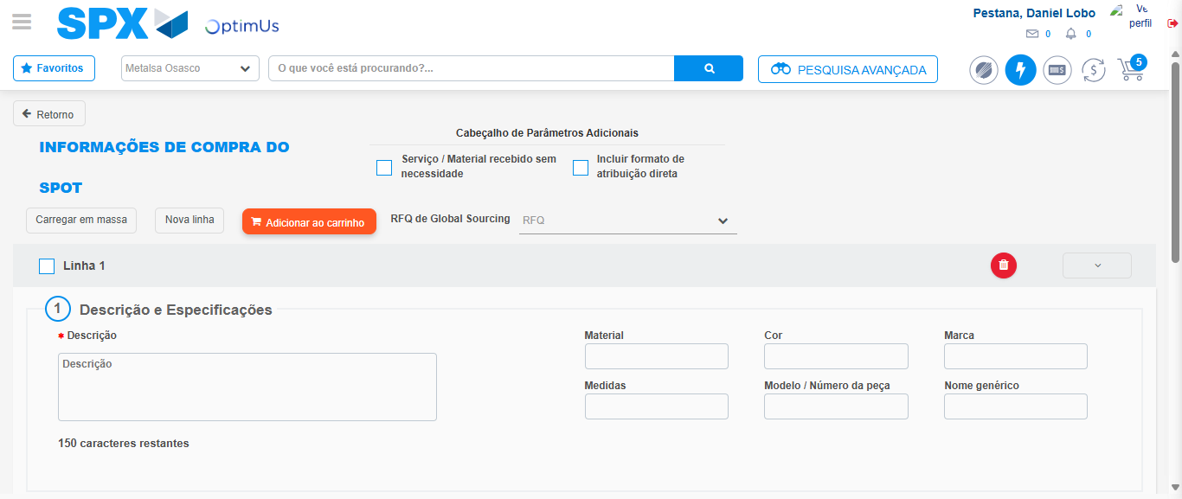Image file-name: QC_Testing-tc006_SPX_Dev5_Crear_Requisicion_Spot_Tipo_Cobro_Proyect_Urgent-1784214513303

Step 3 - Data Capture Spot Buy Requisition: Data captured correctly
Image file-name: QC_Testing-tc006_SPX_Dev5_Crear_Requisicion_Spot_Tipo_Cobro_Proyect_Urgent-1784214513620

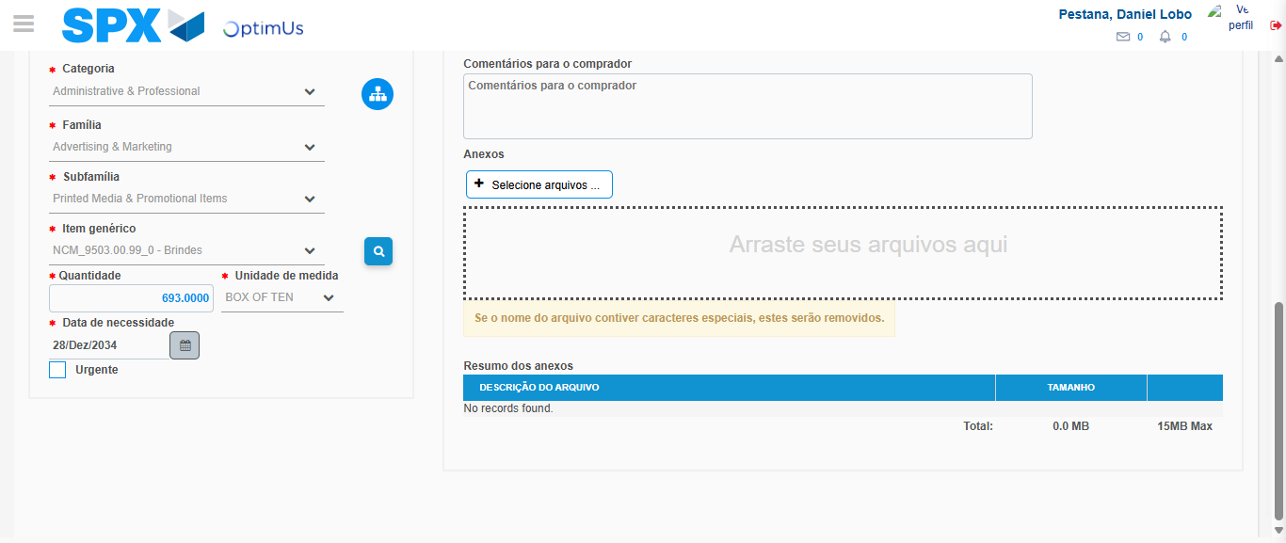Image file-name: QC_Testing-tc006_SPX_Dev5_Crear_Requisicion_Spot_Tipo_Cobro_Proyect_Urgent-1784214527901

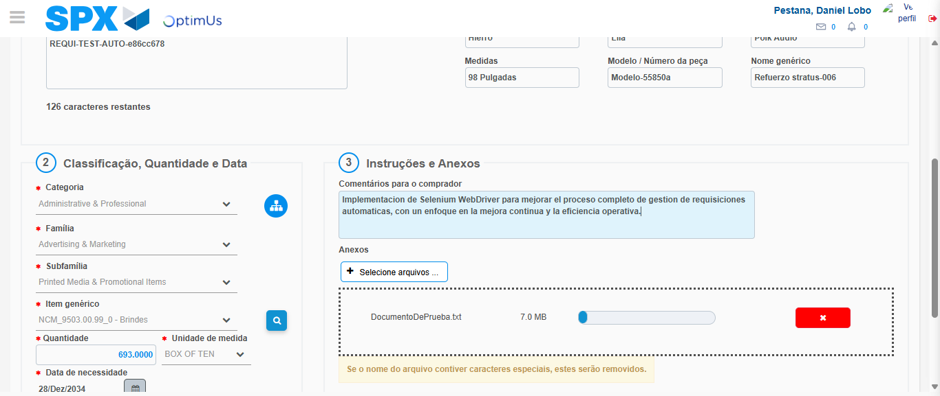Image file-name: QC_Testing-tc006_SPX_Dev5_Crear_Requisicion_Spot_Tipo_Cobro_Proyect_Urgent-1784214528903

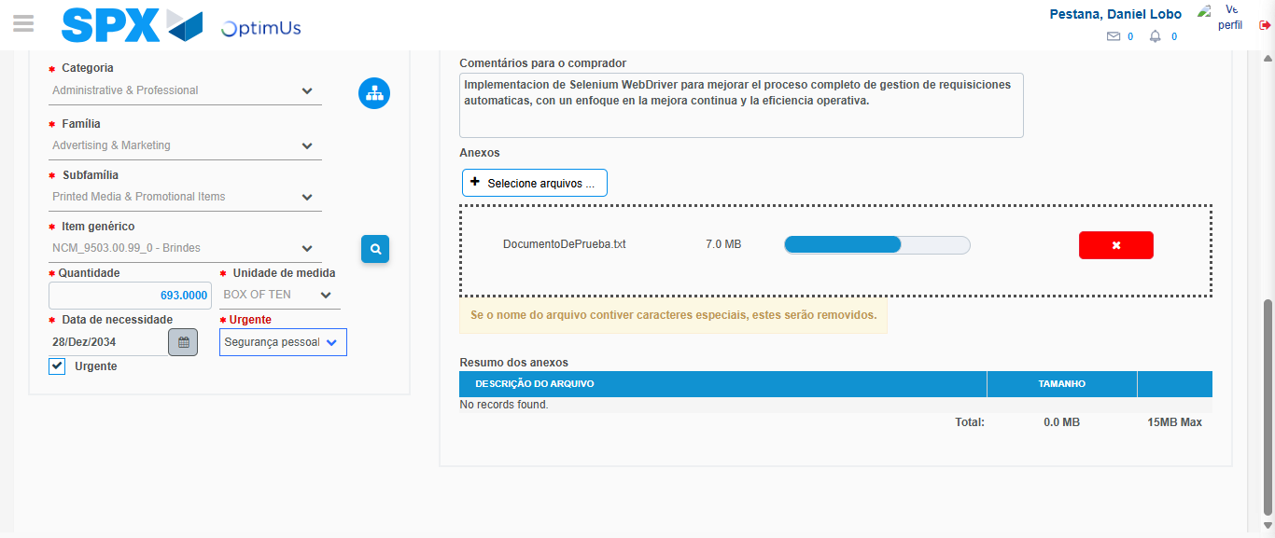Image file-name: QC_Testing-tc006_SPX_Dev5_Crear_Requisicion_Spot_Tipo_Cobro_Proyect_Urgent-1784214532912

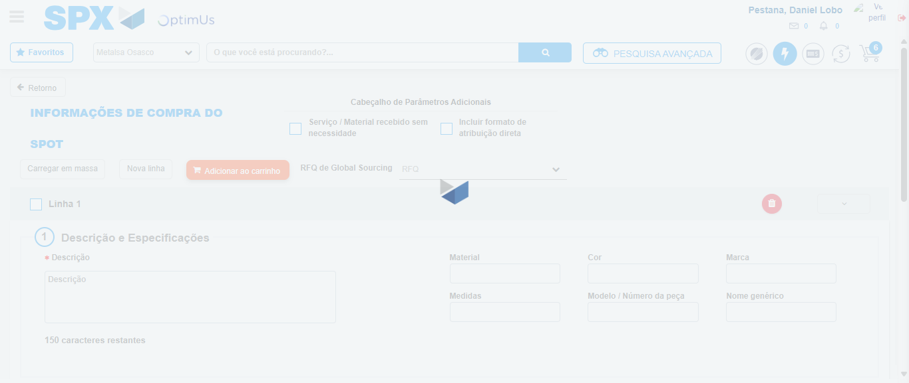Image file-name: QC_Testing-tc006_SPX_Dev5_Crear_Requisicion_Spot_Tipo_Cobro_Proyect_Urgent-1784214534532

Step 7 - Return to Main Page SPX : Return to Main Page SPX
Image file-name: QC_Testing-tc006_SPX_Dev5_Crear_Requisicion_Spot_Tipo_Cobro_Proyect_Urgent-1784214488434

Image file-name: QC_Testing-tc006_SPX_Dev5_Crear_Requisicion_Spot_Tipo_Cobro_Proyect_Urgent-1784214491175

Image file-name: QC_Testing-tc006_SPX_Dev5_Crear_Requisicion_Spot_Tipo_Cobro_Proyect_Urgent-1784214513303

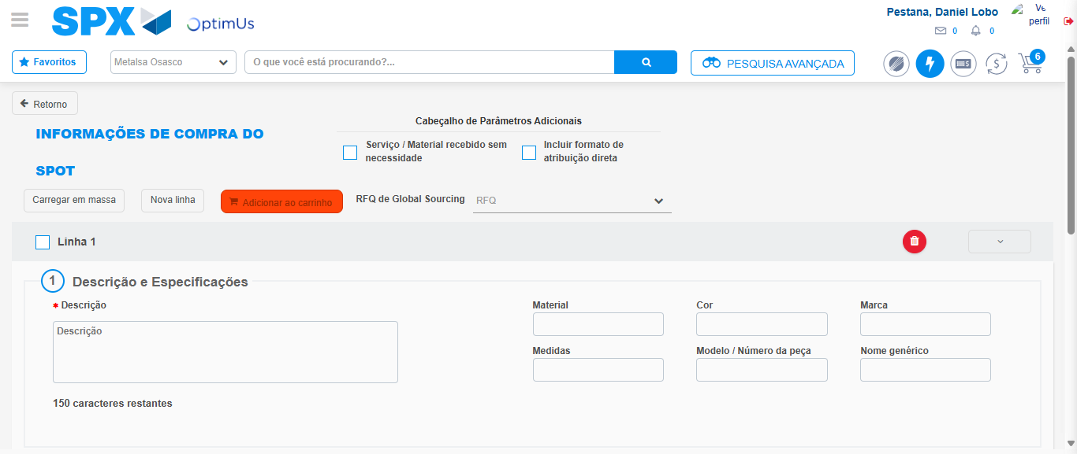Image file-name: QC_Testing-tc006_SPX_Dev5_Crear_Requisicion_Spot_Tipo_Cobro_Proyect_Urgent-1784214536870

Image file-name: QC_Testing-tc006_SPX_Dev5_Crear_Requisicion_Spot_Tipo_Cobro_Proyect_Urgent-1784214537084

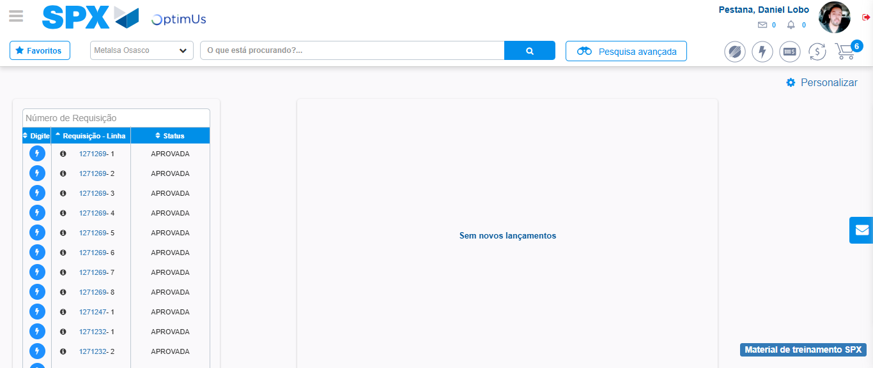Image file-name: QC_Testing-tc006_SPX_Dev5_Crear_Requisicion_Spot_Tipo_Cobro_Proyect_Urgent-1784214558265

Step 8 - Log Out : Log Out SPX
Image file-name: QC_Testing-tc006_SPX_Dev5_Crear_Requisicion_Spot_Tipo_Cobro_Proyect_Urgent-1784214558479

